84.07.30
From James Roberts
RB MSS M136, Library, Royal Botanic Gardens Melbourne.

York Nursery Kew
July 30th 84
Dear Baron
Your note to hand this morning about time you would receive my letter & parcel with fl stem & fruit. I have another plant and I think will flower on the other side I send you a rough sketch of the plant as near as may be, I'm not a good hand at drawing but the stem I sent you Except the size of leaves is simular to the growth of the cane? when I got it and the growth this year the cane I sent you was last year's growth and if you will Examine it the first ½ former leaf you will find the old bloom stem I think both plants I have are alike in the position of flower spike (Erect), the flowers came awkward upside down the best of them — It only last 4 or 5 day and the petals drop off leaving the labellum to the Seed Vesel it appears to set its fruit easily. I pinched all off Except the one left on the specimen I sent you, I was desirous to see if it would ripen so took all others off to give it a chance the first flowers were almost as large as my sketch the upper petal was central and larger & broader than rest and of the Color described It appears to me a curious phajus on a/c of the cane like stem and in not having Bulbous roots, but a sort of Creeping Rhizome I think no 1 is a distinct plant. I have written to Layard about both — I think I told you when he sent it he said he had not seen it before and picked it up accidently while gathering a case of stuff for me — there is a beautiful yellow one & I believe a white one that I have not yet bloomed I believe a most beautiful thing blooms like a Tritoma almost but I believe that is a Calanthe I anticipate finding a lot of things that is not much if at all Known Especially if I get well into the mountains — this Plant grows 12 to 15 inches high, blooms in Each case from the first bract leaf this leaf is above 3 (generally) of these bracts that clasp the stem and they are so tight round the fruit that you cannot remove them with slitting them down, as far as the position of the flower stem is concerned the sketch shows Exactly where it rises, the old canes showed the same that was on the plants when they came
What do you think No 1 is —
With very kind regards
trusting you are getting better
I Remain regardfully
Yours
James Roberts

Thanks for the Pkt of seeds

BB.B bracts close round the stem Clasping close, 2-3
C. bloom spike from ½ grown bract leaf — there are 2 or 3 of these abnormal leaves then 4 or 5 full grown leaves at the top alternate the petiole clasping the stem both bracts & leaves spring from those Bamboo like Joints and all are alternate from root stock to top, —
12 to 15 inches high
It has no Pseudo Bulbs, or more properly bulbs like P. Grandifolius but more like ginger roots. the roots spring out of the stems also above ground — this said stem does not die down like other Phaius at least it has not done so yet after blooming but remains green with the leaves on, full grown leaves 9 inches long 2½ in broad no midrib but furrowed like Phaius of a moderately dark green
first flowers very nearly as large as this sketch
the upper or dorsal petal was largest being broader than the rest all were marked with paralel lines of a sort of yellowish Brown ground color of flower ochre yellow

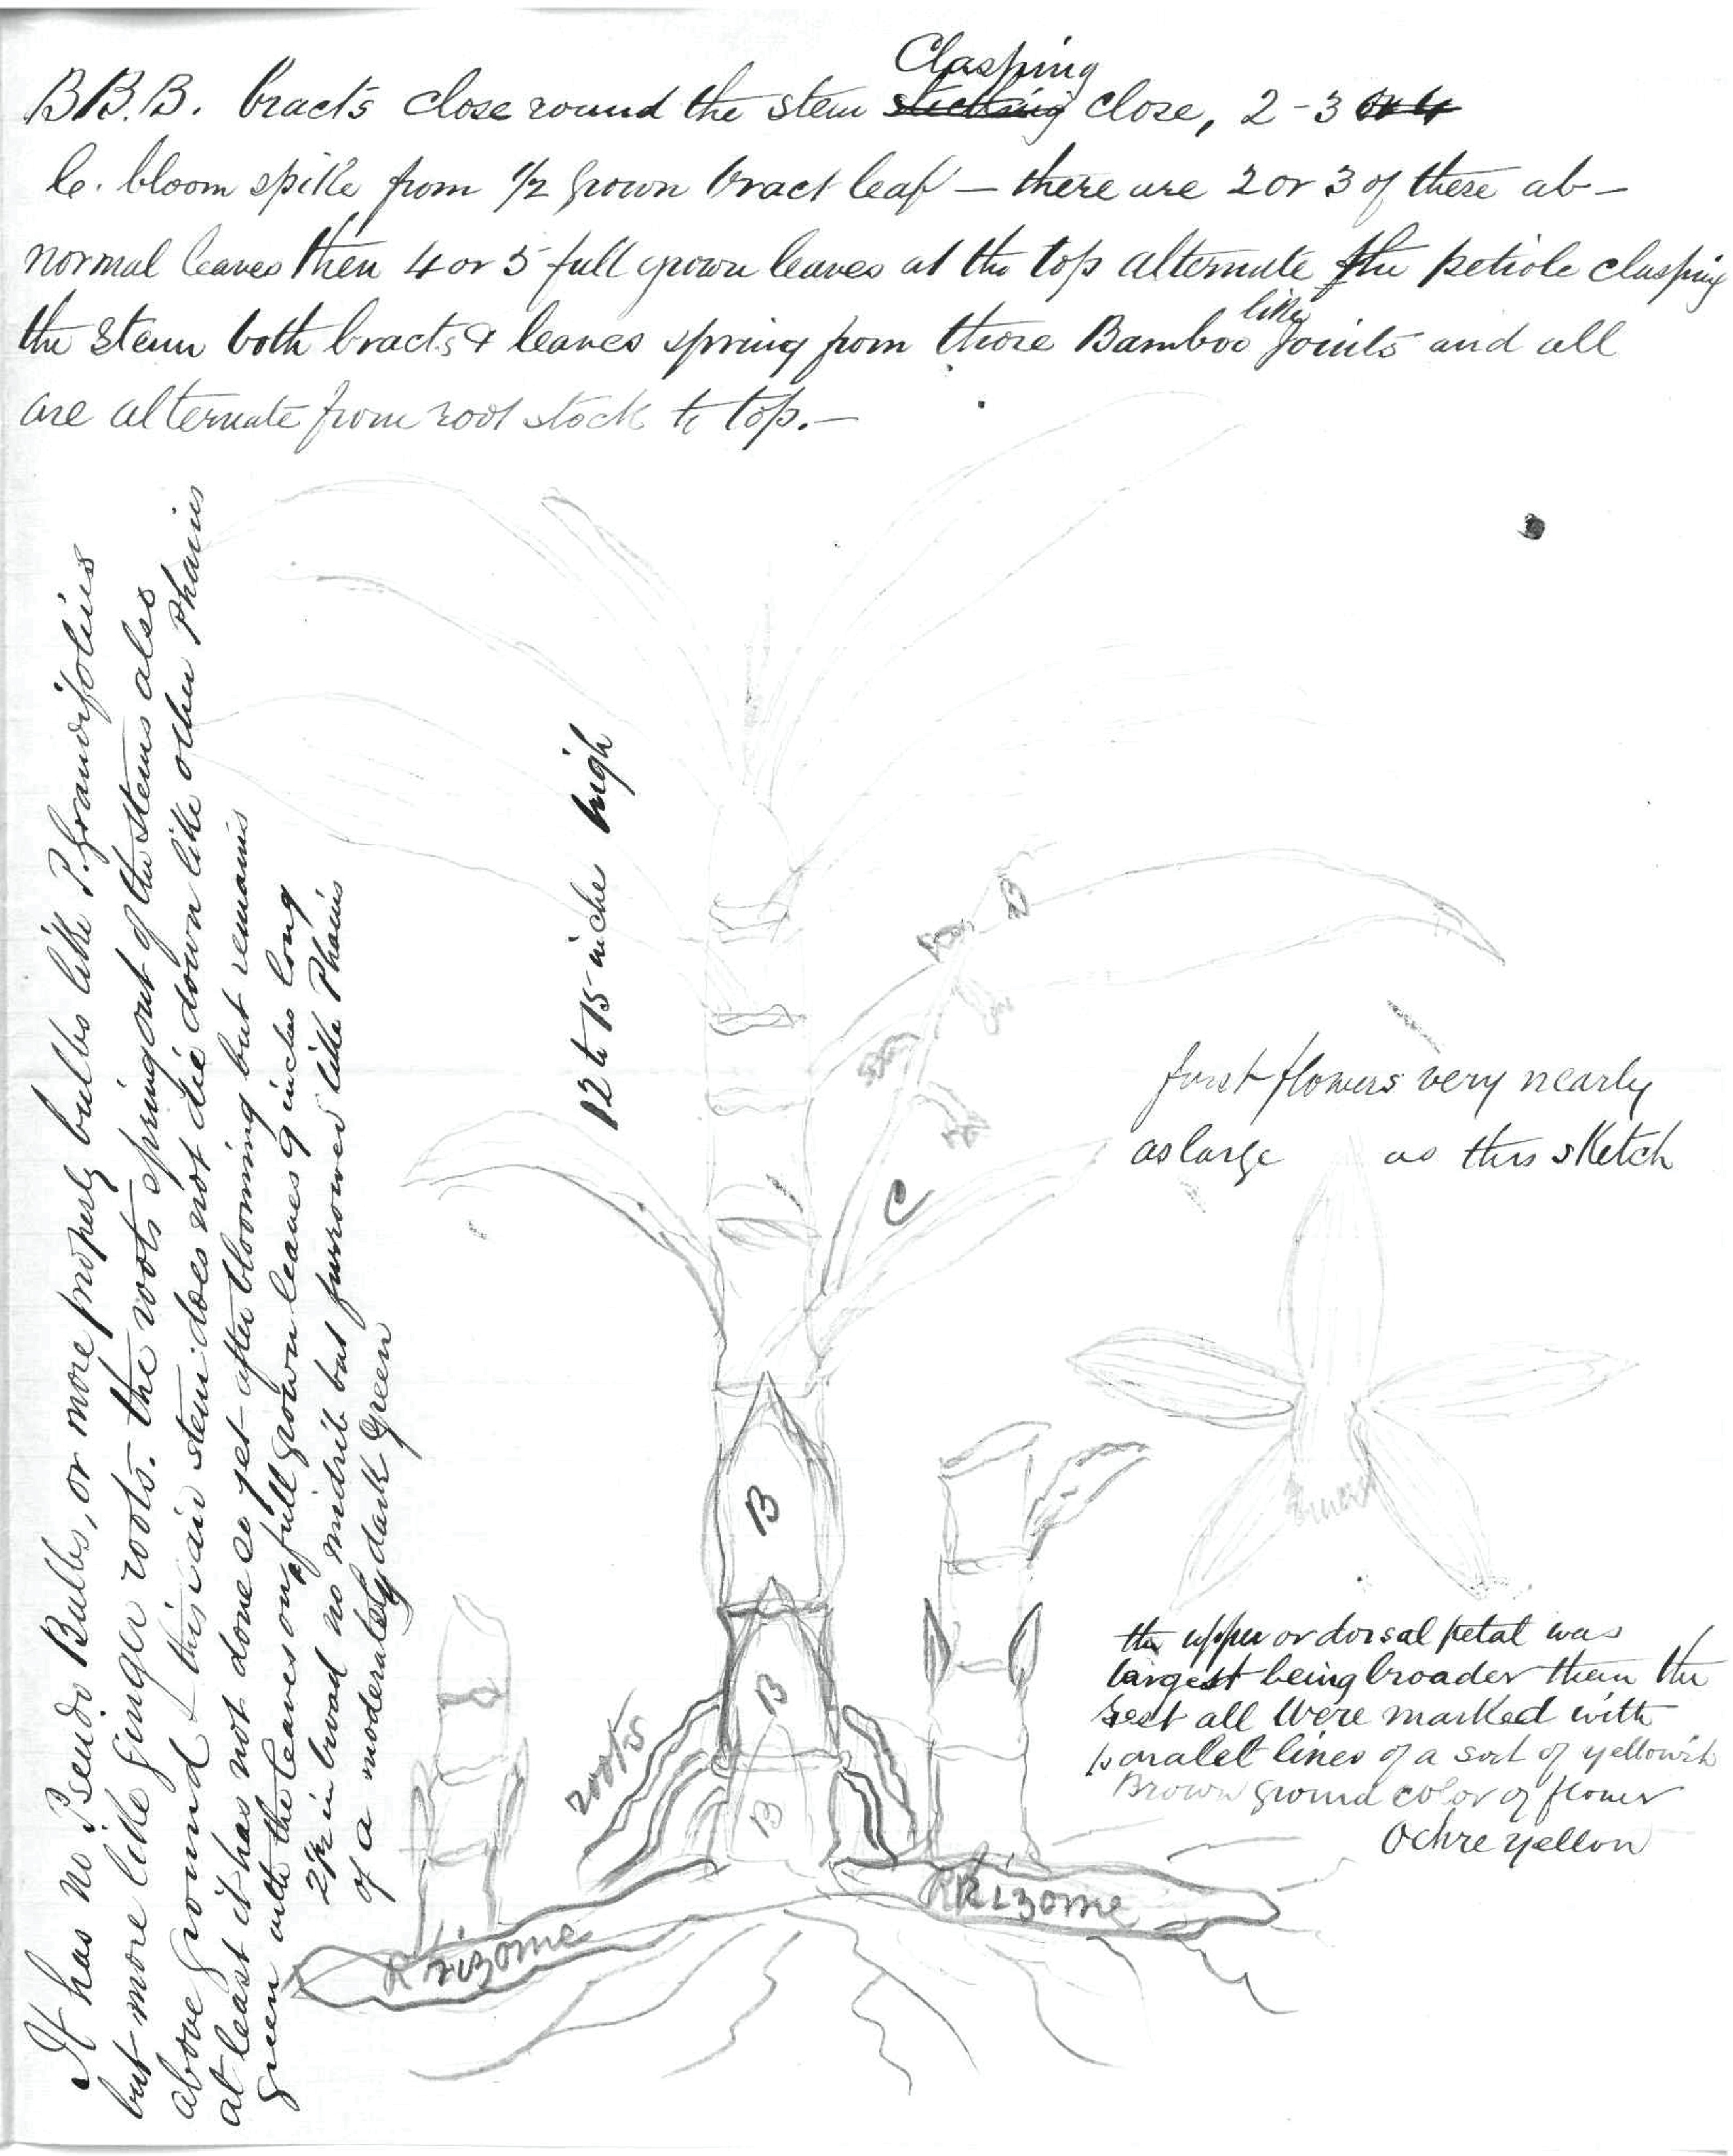

Calanthe
Phaius Grandifolius
phajus
Tritoma

Melbourne.
Letter not found.
See J. Roberts to M, 28 July 1884 (in this edition as 84-07-28b).
flower.
See below.
Tritonia?
The remaining text is annotations to the image that fills the last page of the letter, in the positions shown in the sketch: 84-07-30_image01.jpg The page is 20.5 cm by 25.5 cms.

